Data and Artificial Intelligence Cyber Shujaa Program
Week 9 Assignment
MLOPs

Student Name: Rodney Roy Gitonga
Student ID: CS-DA03-26025

Contents
Contents 1
Introduction 1
Tasks Completed 2
Step 1: Data Loading & Exploration 2
Step 2: Data Preparation 2
Step 3: Model Training and Hyperparameter Tuning 3
Step 4: Evaluation Results and Model Saving 3
Link to Code: 4
Conclusion 4

Introduction
The goal of this project is to build an end-to-end machine learning workflow to predict median house values (in $100,000s) using the California Housing dataset. This dataset features 1990 census data, including eight numerical features such as median income, house age, average rooms, and geographical coordinates.
The primary focus of this assignment is to move beyond simply training a model, and instead engineer a complete, deployable workflow. This involves structuring a data preprocessing Pipeline, utilizing ColumnTransformer for feature scaling and imputation, and applying GridSearchCV to systematically find the optimal hyperparameters for a KNeighborsRegressor model. The final model's predictive success is evaluated using the R-squared (R²) score, alongside Mean Squared Error (MSE) and Root Mean Squared Error (RMSE).

Tasks Completed

Step 1: Data Loading & Exploration
I loaded the dataset directly via scikit-learn's fetch_california_housing utility. Because the end goal is a production-ready pipeline, I fetched the data as a pandas DataFrame for easier feature management and confirmed that it contained the expected 8 features and a target variable.

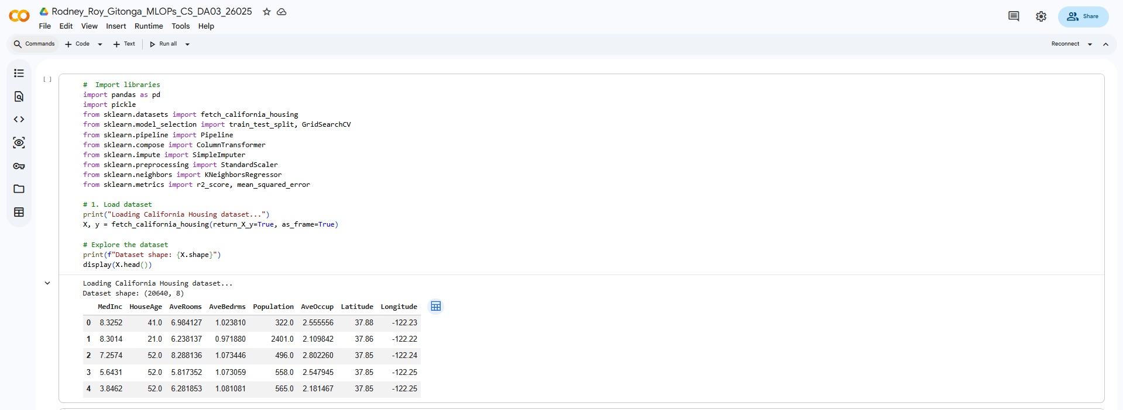

Step 2: Data Preparation
I split the data into an 80% training set and a 20% test set. Because the k-Nearest Neighbors algorithm relies on calculating distances between data points, it is highly sensitive to the scale of the data. Features like 'Population' would completely overshadow features like 'MedInc' (Median Income) without scaling.
To handle this elegantly, I utilized a ColumnTransformer housing a nested Pipeline. This preprocessing pipeline automatically applies a SimpleImputer (to fill any potential missing values with the column mean) followed by a StandardScaler. This preprocessor was then chained directly to the KNeighborsRegressor. 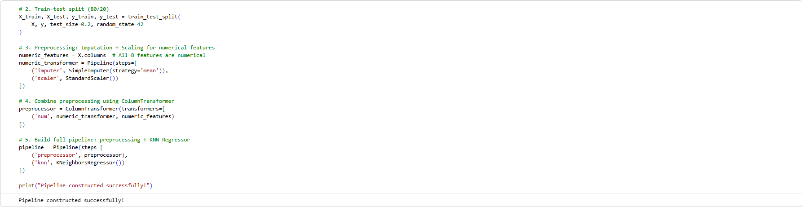

Step 3: Model Training and Hyperparameter Tuning
Instead of guessing the best parameters for the KNN model, I utilized GridSearchCV with 5-fold cross-validation. I tested a grid of hyperparameter combinations:
- n_neighbors: 3, 5, 7, and 9
- weights: 'uniform' (all neighbors weighted equally) vs. 'distance' (closer neighbors have more influence)
- p: 1 (Manhattan distance) vs. 2 (Euclidean distance)
Training the model through the pipeline ensures that standard scaling is applied independently to each fold during cross-validation, strictly preventing data leakage from the validation folds into the training process.
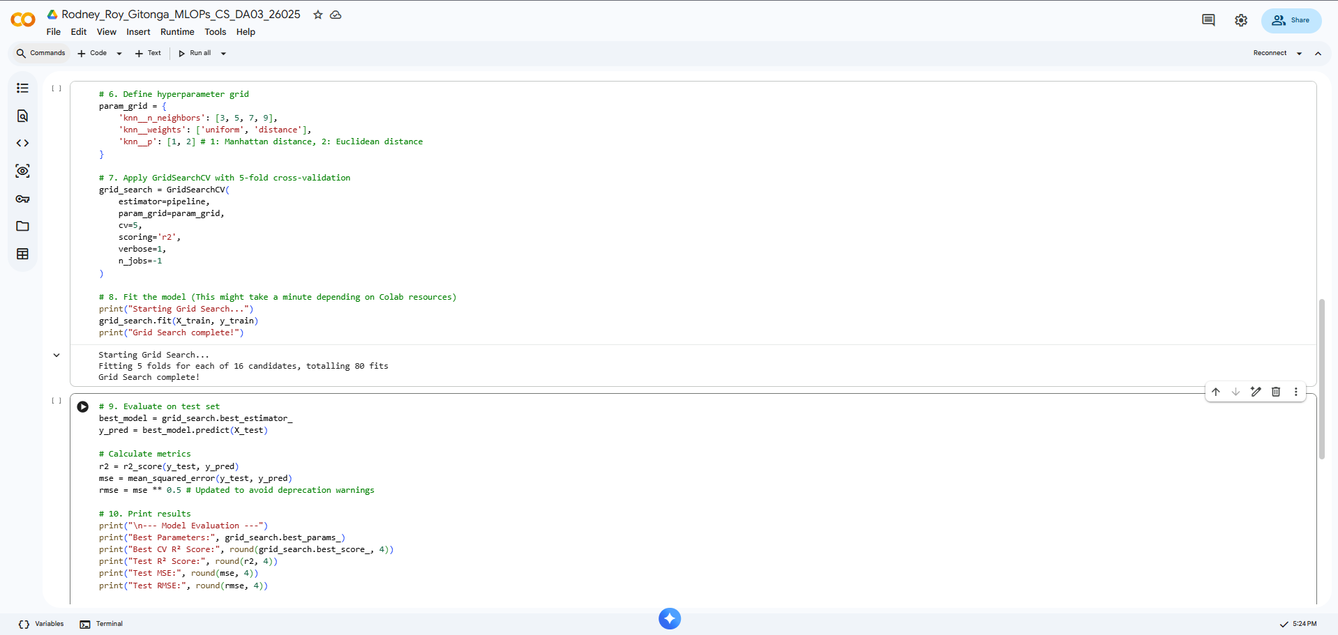

Step 4: Evaluation Results and Model Saving

The Grid Search successfully identified the optimal hyperparameters for the housing data. The model was evaluated on the unseen 20% test set, yielding strong predictive performance. Finally, the entire trained pipeline (which includes both the scaler and the tuned model) was serialized and saved as a .pkl file using the pickle library, making it ready for deployment.
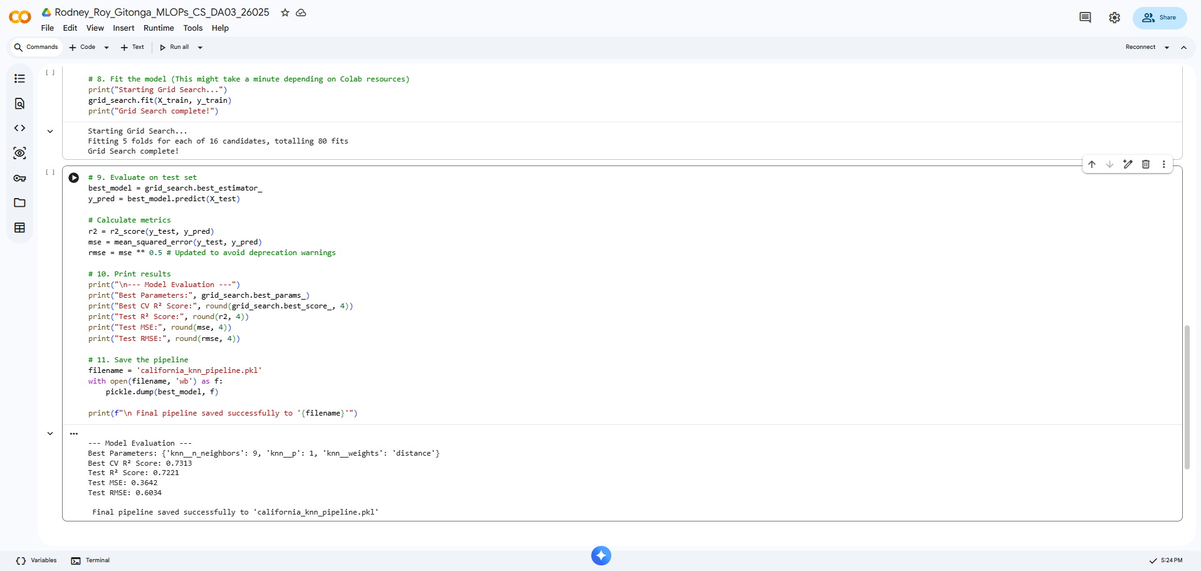

Link to Code:
https://colab.research.google.com/drive/1g7R3DPOvgKXPO8-zE9VvYrpDA69TMC0R?usp=sharing

Conclusion
This assignment effectively demonstrated the architecture of a professional machine learning workflow. By wrapping the preprocessing steps (imputation and scaling) and the estimator (KNN) into a single scikit-learn Pipeline, the code became much cleaner and significantly less prone to errors like data leakage during cross-validation.
I learned that hyperparameter tuning via GridSearchCV is a powerful, systematic way to maximize a model's performance, as it exhaustively tests combinations (like switching between Euclidean and Manhattan distances) to find the best fit for the specific geometry of the dataset. Finally, saving the entire pipeline as a .pkl object highlighted how seamlessly a model can be transitioned from a research notebook environment into a deployable state, ready to ingest and predict on new, raw JSON data in a web application.

